American University of Sharjah  School of Engineering  Computer Engineering Department  P. O. Box 26666 Sharjah, UAE |  | Instructor: Dr. Ghassan Z. Qadah  Lab Instructor: Ms. Praveena Kolli  Office: EB2-126  Phone: 971-6-515-2352  e-mail: pkolli@aus.edu  Semester: Spring 2019

CMP305L Data Structures and Algorithms
Lab10
Objectives:
- To understand searching using hashing
- To understand collisions and linear probing
- To understand buckets and chaining
Exercise 1

- A student has an id, a first name and a last name. Define a Student class and implement it by providing all the necessary constructors (default, copy, etc…), overloaded operators, (= and = =), destructor , set and get methods.

class Student{
public :
Student();

Student(int, char*, char*);
Student(const Student &);//copy constructor
~Student();
Student&operator=(const Student&);//Assignment
bool operator ==( const Student &);//Equality
void setId(int value)
int getId();
void setFirstName(char* fname)
cahr* getFirstName ();
void setLastName(char* lname)
char* getLastName ();

private :
int id ;
char* firstName;
char* lastName
};

- The students’ details are given in the file by name student.txt.
- HashTable ADT declaration is given below.
- Write a program to create a HashTable class that store and search for student object.
- Linear probing method must be used.
- Your program must ask the user to enter a student’s Id and display his details.

class HashTable // declares a class data type
{
public :
HashTable ( );
void RetrieveItem(Student& item, bool& found);
ERROR_CODE InsertItem ( Student item );
ERROR_CODE DeleteItem ( Student item );
void print();//print all students
private : // 3 private data members

Student info[MAX_ITEMS] ;
};

- Write a non-member function that takes student id as an argument and prints the details of the student.
- In the main, test all the functionality of HashTable.

Hints:
- The Hash function/table must be created based on students IDs.
- Student class must include the Hash function that returns the hash value used to insert the item into the hash table.

Exercise 2:
Repeat Exercise1 with Buckets and chaining method
Note that each bucket is implemented as UnsortedListType

class HashTable // declares a class data type
{
public :
HashTable ( );
void RetrieveItem(Student& item, bool& found);
ERROR_CODE InsertItem ( Student item );
ERROR_CODE DeleteItem ( Student item );

private : // 3 private data members

ListType* info[MAX_ITEMS] ;
};

/*STUDENT.CPP AN IMPLEMENTATION OF THE STUDENT CLASS*/
#include<iostream>
#include<fstream>
#include<string>
using std::string;
//Choosing a prime number for fun
const int MAX_ITEMS= 101;
class Student
{
private:
int studentID;
string firstName;
string lastName;
public:

Student(){studentID = -1;}
Student(int i, string f, string l): studentID(i), firstName(f), lastName(l){}

//deliberately chosen so there is at least one collision
int Hash(){return studentID%MAX_ITEMS;}

int getID() const{return studentID;}
string getFirst() const {return firstName;}
string getLast() const {return lastName;}

//copy constructor
Student(const Student & s): Student(s.studentID, s.firstName, s.lastName){}
~Student(){}

Student&operator=(const Student& s){
if(this != &s){
studentID = s.studentID;
firstName = s.firstName;
lastName = s.lastName;
}
return *this;

}

/*
I'm going to assume the ID of a student never changes once assigned, and therefore there's no need to provide a mutator.

Why? Consider the case where hash(old_ID) = a, and hash(new_ID) = b, where a !=b.
Moving student from info[a] to info[b] would remove a lot of the elegance of our solution
*/
void remove(){studentID = -1;}
void setFirst(string f){firstName = f;}
void setLast(string l){lastName = l;}

inline friend bool operator<(const Student& s1, const Student& s2){return s1.getID() < s2.getID();}
inline friend bool operator>(const Student& s1, const Student& s2){return s2 < s1;}
inline friend bool operator==(const Student& s1, const Student& s2){return s1.getID() == s2.getID();};

friend std::ostream& operator<<(std::ostream& cout, const Student& s){cout << s.getID() << " " << s.getFirst() << " " << s.getLast();return cout;};

};

/*Hash table header file for linear probing*/
#ifndef HashTable_H
#define HashTable_H
#include "Student.cpp"

enum ERROR_CODE{OVERFLOW, UNDERFLOW, SUCCESS};

//this hash table memory game WEAK af
class HashTable // declares a class data type
{
public :
HashTable ( );
void RetrieveItem(Student& item, bool& found);
ERROR_CODE InsertItem ( Student item );
ERROR_CODE DeleteItem ( Student item );
void print();//print all students
private : // 3 private data members

Student info[MAX_ITEMS] ;
};
#endif

/*HashTable.cpp A C++ implementation of hash tables with linear probing*/
#include"HashTable.h"
HashTable::HashTable ( ){}
//you should really just return a bool over here it would be so much better
void HashTable::RetrieveItem(Student& item, bool& found){
found = false;
int hash = item.Hash();
for(int i = 0; i < MAX_ITEMS; ++i){
if(info[(hash+i)%MAX_ITEMS] == item){
item = info[(hash+i)%MAX_ITEMS];
found = true;
break;
}
}

}
ERROR_CODE HashTable::InsertItem ( Student item ){
int i = 0;
int hash = item.Hash();
while(info[(hash+i)%MAX_ITEMS].getID() != -1){
if(++i == MAX_ITEMS){return OVERFLOW;}
}
info[(hash+i)%MAX_ITEMS] = item;
return SUCCESS;

}

//this really doesn’t need to be of type ERROR_CODE
ERROR_CODE HashTable::DeleteItem ( Student item ){
int hash = item.Hash();
for(int i = 0; i < MAX_ITEMS; ++i){
if(info[(hash+i)%MAX_ITEMS] == item){
info[(hash+i)%MAX_ITEMS].remove();
return SUCCESS;
}
}
return UNDERFLOW;
}
void HashTable::print(){
for(Student s : info){
if(s.getID() != -1){
std::cout << s << std::endl;
}
}
}

//One of the questions asks for us to print the student given their ID
//This is trivial to do with just the ID when the hash table is global
//Of course, in general, global variables are to be avoided
//So I made this non-member function that takes the table as a second argument
//And returns the student with their details all updated (if the ID exists in the table)
//If the ID is not found it just returns a student with ID = -1
//I still cannot fathom why Dr. Ghassan is so fond of "found"

Student getStudent(int ID, HashTable table, bool& found){
Student s(ID, "", "");
table.RetrieveItem(s, found);
if(found){return s;}
else{
Student p;
return p;
}
}

int main(){
HashTable table;
int ID;
string fname;
string lname;

std::ifstream fin("student.txt");
if(fin.fail()){std::cerr << "Error opening student file!"; exit(1);}

while(fin >> ID >> fname >> lname){
Student s(ID, fname, lname);
if(table.InsertItem(s) == OVERFLOW){std::cout << "Could not insert student with ID" << ID << std::endl; break;}
}

fin.close();

std::cout << "Students before deleting a person" << std::endl;
table.print();

bool found = false;
Student s;
while(!found){
std::cout << "Enter student ID to retrieve and delete" << std::endl;
std::cin >> ID;
s = getStudent(ID, table, found);
}
std::cout << "The student who you are removing/graduating is:" << std::endl;
//making custom print functions is dumb when you can just do operator overloading
std::cout << s << std::endl;
table.DeleteItem(s);
std::cout << "Students after you murdered/expelled that poor dude" << std::endl;
table.print();

return 0;
}

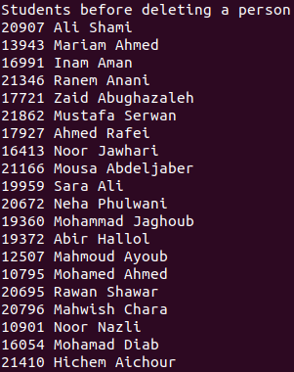
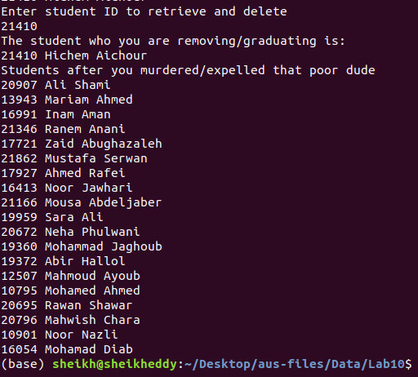

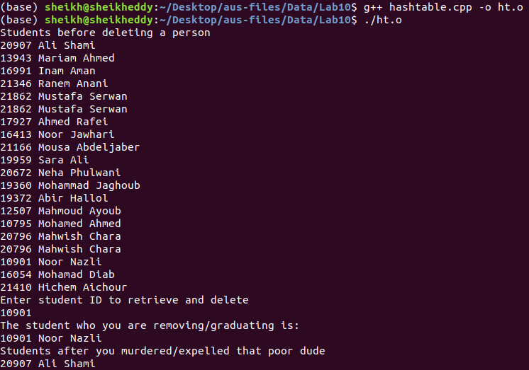
#include<iostream>#include<fstream>
#include "Student.cpp"
#include "UnsortedType.cpp"

#define ListType UnsortedType

enum ERROR_CODE{OVERFLOW, UNDERFLOW, SUCCESS};

class hashtable
{
public :
hashtable ( );
~hashtable( );
void RetrieveItem(Student& item, bool& found) const;
ERROR_CODE InsertItem ( Student item );
ERROR_CODE DeleteItem ( Student item );
void print();
private :

ListType* info[MAX_ITEMS] ;
};

hashtable::hashtable(){
for(int i = 0; i < MAX_ITEMS; ++i){
info[i] = new ListType;
}
}

hashtable::~hashtable(){
for(int i = 0; i < MAX_ITEMS; ++i){
if(info[i]){delete info[i];}
}
}

void hashtable::RetrieveItem(Student& item, bool& found) const{
found = false;
int hash = item.Hash();
info[hash]->RetrieveItem(item, found);
}

ERROR_CODE hashtable::InsertItem ( Student item ){
int hash = item.Hash();
info[hash]->InsertItem(item);
if(info[hash] == nullptr){
return OVERFLOW;
}
return SUCCESS;

}
ERROR_CODE hashtable::DeleteItem ( Student item ){

int hash = item.Hash();
if(info[hash]==nullptr){
return UNDERFLOW;
}

info[hash]->DeleteItem(item);
return SUCCESS;
}
void hashtable::print(){
for(int i = 0; i < MAX_ITEMS; ++i){
if(!(info[i]->IsEmpty())){
Student s;
info[i]->ResetList();
for(int j = 0; j < info[i]->Length(); ++j){
info[i]->GetNextItem(s);
if(s.getID() != -1){
std::cout << s << std::endl;
}
}
}
}
}

//One of the questions asks for us to print the student given their ID
//This is trivial to do with just the ID when the hash table is global
//Of course, in general, global variables are to be avoided
//So I made this non-member function that takes the table as a second argument
//And returns the student with their details all updated (if the ID exists in the table)
//If the ID is not found it just returns a student with ID = -1
//I still cannot fathom why Dr. Ghassan is so fond of "found"

Student getStudent(int ID, const hashtable& table, bool& found){
Student s(ID, "", "");
table.RetrieveItem(s, found);
return s;
}

int main(){
hashtable table;

int ID;
string fname;
string lname;

std::ifstream fin("student.txt");
if(fin.fail()){std::cerr << "Error opening student file!"; exit(1);}

while(fin >> ID >> fname >> lname){
Student s(ID, fname, lname);
if(table.InsertItem(s) == OVERFLOW){std::cout << "Could not insert student with ID" << ID << std::endl; break;}
}

fin.close();

std::cout << "Students before deleting a person" << std::endl;
table.print();

bool found = false;
Student s;
while(!found){
std::cout << "Enter student ID to retrieve and delete" << std::endl;
std::cin >> ID;
s = getStudent(ID, table, found);
}
std::cout << "The student who you are removing/graduating is:" << std::endl;
//making custom print functions is dumb when you can just do operator overloading
std::cout << s << std::endl;
table.DeleteItem(s);
std::cout << "Students after you murdered/expelled that poor dude" << std::endl;

table.print();

return 0;
}

#include<iostream>
using namespace std;
#define ItemType Student

struct NodeType{

ItemType info;
NodeType* next = nullptr;

};

class UnsortedType
{
public :
// LINKED LIST IMPLEMENTATION
UnsortedType ( ) ;
void MakeEmpty ( ) ;
bool IsFull ( ) const ;
bool IsEmpty() const;
int Length ( ) const ;
void RetrieveItem ( ItemType& item, bool& found ) const;
void InsertItem ( ItemType item ) ;
void DeleteItem ( ItemType item ) ;
void ResetList ( );
void GetNextItem ( ItemType& item ) ;
friend UnsortedType operator &(const UnsortedType &list1, const UnsortedType &list2);
friend UnsortedType operator|(const UnsortedType &list1, const UnsortedType &list2);
~UnsortedType ( ) ; //one of the three safety functions
UnsortedType(const UnsortedType& original);
UnsortedType& operator=(const UnsortedType& original);
private :
NodeType* listData; //this is the "head" of the list
int length; //there is absolutely no need for this, but whatever
NodeType* currentPos;
};

UnsortedType::UnsortedType ( ) {
length = 0 ;
listData = nullptr; //prefer nullptr over null in newer code
currentPos = new NodeType;
}

UnsortedType& UnsortedType::operator=(const UnsortedType& original){
if(this->listData != original.listData){
MakeEmpty();
listData = nullptr;
length = 0;
currentPos = new NodeType;
NodeType* tmp = original.listData;

while(tmp){
InsertItem(tmp->info);
tmp = tmp->next;
}

}

return *this;

}

UnsortedType::UnsortedType(const UnsortedType& original){
listData = nullptr;
length = 0;
NodeType* tmp = original.listData;
currentPos = new NodeType;

while(tmp){
InsertItem(tmp->info);
tmp = tmp->next;
}
}

//I'm not just setting listData to null
//because otherwise the nodes don't get freed
void UnsortedType::MakeEmpty ( ) {
if(!IsEmpty()){
while(listData){
DeleteItem(listData->info);
}
delete currentPos;
}

}

bool UnsortedType::IsFull ( ) const {
NodeType* location;
try{
location = new NodeType;
delete location;
return false;
}catch(std::bad_alloc exception){
return true;
}

}
bool UnsortedType::IsEmpty() const{return listData == nullptr;}
int UnsortedType::Length ( ) const {
return length;
}
void UnsortedType::RetrieveItem ( ItemType& item, bool& found ) const{
NodeType* location = listData ;
found = false ;
while (location && !found ){
if ( item == location->info ){ // operator==
found = true; // match found
item = location->info;
}
else // advance pointer
location = location->next;
}

}
void UnsortedType::InsertItem ( ItemType item ){
if(!IsFull()){
NodeType* location ;
// obtain and fill a node
location = new NodeType;
location->info = item ;
location->next = listData;
listData = location ;
length++;
}
}

void UnsortedType::DeleteItem ( ItemType item ){
if(IsEmpty()){return;}

NodeType* location = listData;
NodeType* tmp = new NodeType;

// locate node to be deleted
if (item == listData -> info){
tmp = listData;
listData = listData ->next;
}
else{
while (location->next && !(item == (location -> next)->info))
location = location -> next;
// delete node at location -> next
tmp = location -> next;
location -> next = (location -> next) -> next;
}
delete tmp;
length--;

}

void UnsortedType::ResetList ( ){

if(listData){ //prevent dereferencing of null pointer
currentPos->next = listData;
currentPos->info = listData->info;
}

}

void UnsortedType::GetNextItem ( ItemType& item ){
if(currentPos){ //prevent dereferencing of null pointer
item = currentPos->info;
currentPos = currentPos->next;
}else{
currentPos = listData;
currentPos->next = listData->next;
currentPos->info = listData->info;
item = currentPos->info;
}

}
UnsortedType::~UnsortedType ( ){
MakeEmpty();
} //one of the three safety functions
UnsortedType operator &(const UnsortedType &list1, const UnsortedType &list2){
UnsortedType intersection;

ItemType item;
bool found; //no need to set to false cause RetrieveItem does it for us
int size = list1.Length() < list2.Length() ? list1.Length() : list2.Length();
NodeType* shorter = size == list1.Length() ? list1.listData : list2.listData;
const UnsortedType* longer = size == list1.Length() ? &list2 : &list1; //preserve constness
//I don't like doing it this way tbh but I've been deducted points for "inefficiency" before

for(int i = 0; i < size; ++i){

item = shorter->info;
shorter = shorter->next;
longer->RetrieveItem(item, found);

if(found){
intersection.RetrieveItem(item, found);
if(!found){
intersection.InsertItem(item);
}
}
}

return intersection;
}
UnsortedType operator|(const UnsortedType &list1, const UnsortedType &list2){
UnsortedType result(list1);

NodeType* tmp = list2.listData;
ItemType item;
bool found;

for(int i = 0; i < list2.Length(); ++i){
item = tmp->info;
tmp = tmp->next;
result.RetrieveItem(item, found);
if(!found){result.InsertItem(item);}
}

return result;
}

